INSTAGRAM @ INDONESIABAIK.ID ACCOUNT MANAGEMENT STRATEGY AS A MEDIUM FOR DISSEMINATING PUBLIC INFORMATION

Sri Dewi Larasati¹, Dwi Kartikawati²
Universitas Nasional Jakarta, Indonesia
*e-mail: sdewilarasati05@gmail.com¹, dwi.kartikawati@civitas.unas.ac.id²

Keywords |  | ABSTRACT
Strategy, Management, Media, Public Information Dissemination |  | Social media is a platform that allows users to engage in interaction, collaboration, and the formation of virtual social communities. Social media plays an important role in the dissemination of information. This research aims to study how to manage Instagram accounts owned by the Indonesian government, namely, Indonesian accounts belonging to Kominfo. The research uses a qualitative approach to gather in-depth narratives and detailed accounts from informants. The data was collected through interviews, observations, and literature studies. Finally, the data was interpreted to answer the research questions and provide meaningful insights. This study contributes to understanding the effective management of social media platforms, specifically Instagram, as a tool for disseminating public information. The study provides insights into strategies and practices that can optimize social media usage for public communication, enhancing engagement, information accessibility, and public awareness. This could provide further insights into optimizing social media strategies for public information dissemination.

INTRODUCTION
The development of technology has far-reaching consequences to be able to benefit humans in various ways, including in the field of communication. The presence of various computer media, smartphones, and the Internet marks an advance in communication and information technology affects the way humans communicate easily and how to obtain information without any obstacles (Imamov & Semenikhina, 2021; Marani et al., 2020; Mustapha et al., 2022; Putri & Irwansyah, 2020; Szymkowiak et al., 2021). By utilizing the Internet, individuals can obtain unlimited information. Based on a survey conducted by the Indonesian Internet Service Providers Association (APJII) and released on May 15, 2023, the number of individuals in Indonesia who were connected to the Internet during the 2022-2023 period amounted to 215.62 million people (APJII, 2023). This figure represents the majority of the total population of 275.77 million individuals in 2022. In 2023, there will be an increase of 78.19 percent in terms of internet penetration. The advancement of Internet penetration has played an important role in the emergence of new forms of media, especially social media. With social media, it allows users to engage in interaction, collaboration, and the formation of virtual social communities.
Social media is considered the main source of information to have a greater contribution to the dissemination of information than other media such as electronic and print media (Khan et al., 2021; Kington et al., 2021; Thompson et al., 2020; Tsfati et al., 2020; Vraga & Tully, 2021). In a survey report by the Ministry of Communication and Information Technology (Kemenkominfo) and the Katadata Insight Center (KIC) released in February 2023, it was reported that in the last three years, social media has become the main source of information for the Indonesian people (Annur, 2023). The report shows that 73% of respondents used social media as their source of information in 2022. Other main sources of information are online news at 25.2%, print media at 16.4%, and government websites at 14%. Social media management is an important role for an institution because social media is used as a platform to interact, collaborate, receive and share information. With good social media management, it will produce the necessary content according to the target public target to achieve the goal maximally. Government agencies or institutions have begun to use social media to disseminate public information regarding policies, work plans, and performance achievements, as well as provide information services to the public as a form of application of Law Number 14 of 2008 concerning Public Information Disclosure (KIP). This is to encourage public information disclosure as a form of public supervision of the administration of the state and other public bodies that are considered important, and affect the lives of the Indonesian people. Instagram is one of the social media that is quite popular and is used as a dissemination of information. Social media is a communication space built for the community to obtain and be able to listen to the aspirations of the community. According to the We Are Social Report reported by DataReportal, Instagram occupies the second position as the social media that is often used by Indonesians in 2023 with a percentage of 86.5 (We are Social, 2023).
The Ministry of Communication and Information Technology (Kemkominfo) as a Public Agency has integrated the internet as one of the tools for disseminating public information, one of which is by launching a social media-based Indonesiabaik.id program and websites. The Indonesiabaik.id website is a media that disseminates public information about government programs and policies that target its target audience of young Indonesians aged 18-34 years and digital natives to prepare for the 2030 demographic bonus. Indonesiabaik.id in disseminating public information using various social media such as Twitter, YouTube, TikTok, Facebook. Instagram social media is one of the media that is actively used by Indonesiabaik.id. The @indonesiabaik.id Instagram account was recorded on June 28, 2023, has 430 thousand followers and has uploaded 8,382 posts. When compared to other social media owned by Indonesiabaik.id such as the Twitter account with 34.2 thousand followers, Facebook with 200 thousand followers, TikTok with 5486 followers, and YouTube with 22.3 thousand subscribers recorded on July 12, 2023, far from its Instagram account.
The @indonesiabaik.id account is present in the midst of a concern regarding the amount of negative content circulating, especially social media (Kominfo, 2017). This is because on social media the truth of information is very difficult to measure, because everyone who uses it can spread information quickly, regardless of whether it is true or not, even to spread hoaxes. The @indonesiabaik.id account presents positive content that comes from official sources and is valid as a digital literacy medium. The community, especially the younger generation who use social media a lot, must continue to be encouraged to create and viral positive content.
As a government media that disseminates public information by keeping up with the times, Indonesiabaik.id received an award from the World Summit on the Information Society (WSIS) organized by the International Telecommunication Union (ITU) in Geneva, Switzerland held on March 19-23, 2018 which discussed issues related to Information and Communication Technology (ICT) from around the world and was assessed by a group of experts from the United Nations (UN) and to participate in the public to vote. Indonesiabaik.id received the title of winner in the "media" category because it is considered the most viral government portal for public policy based on the assessment and the most votes on the voting of the event (Kominfo, 2018).
In this research, the author focuses on the Instagram account @indonesiabaik.id owned by the Ministry of Communication and Information Technology (Kominfo) because it has a level of interactivity as a government media that is quite active in disseminating public information. Good media management to meet the information needs of its followers. Through the content of the content as a whole, it can be an image of the agency for the community in the midst of a lot of negative content circulating so that it needs to be encouraged to develop positive information.
To understand how management in social media is done, the author first conducted a search for various previous researches. In the search for previous research, namely from the one entitled Social media engagement forms in government: A structure-content framework from Wukich (2022), which focuses on social media engagement as a factor that enables responsiveness for organizations that relate to large and diverse audiences. Meanwhile, this research actually looks at how to manage accounts owned by the Indonesian government, namely Indonesian accounts belonging to Kominfo. Then research from Yuan et al. (2023) which focuses on the management of the Chinese government through social media in facilitating people's digital participation in government-initiated technology, which has strategic significance for future programs and policies Chinese government. Meanwhile, the author's research looks at the management of indonesiabaik.co.id accounts as a medium for disseminating information. For the public. The last research search is from A. Hastrida (2021) which aims to manage government social media as an interactive relationship between the government (state authority organizers) and the public through social media. The measure of social media success in this case is the sharing of information, mass collaboration and social transactions. This third research is clearly different considering that the researcher's research focuses directly on the management of Kominfo's special account media so that it can carry out its function as a medium for disseminating public information.
In addition to using the management concept abbreviated as POAC (Planning, Organizing, Actuating and Controlling), it also uses the 4C concept from Chris Heuer, the founder of the Social Media Club and a new media innovator in the use of Social Media, which includes four things in the management of activities on social media, including (Solis & Kutcher, 2010): 1. Context: "How we frame our stories." The meaning is how we shape a story or message (information) like the form of a message itself, by using certain language in conveying the message. 2. Communication: "The practice of sharing our sharing story as well as listening, responding, and growing." It is how to string together in sharing stories or information as well as we hear, respond and grow in various ways that make users feel comfortable and the message is conveyed well. 3. Collaboration: "Working together to make things better and more efficient and effective." It is how to work together in making things better efficiently and effectively 4. Connection: "The relationships we forge and maintain." It is how to maintain the relationships that have been built. Chris Heuer thinks that social media management is useful for convenience and fulfilling planned goals and realizing effective communication.
The research aims to study how to manage the Instagram @indonesiabaik.id media account as a medium for disseminating public information. The research contributes to understanding the effective management of social media platforms, specifically Instagram, as a tool for disseminating public information. By focusing on the case of the @indonesiabaik.id account, the study provides insights into strategies and practices that can optimize social media usage for public communication, enhancing engagement, information accessibility, and public awareness. This research is valuable for public institutions, government agencies, and media managers seeking to utilize social media to effectively communicate with the public.

METHODS
This research employs a qualitative approach to gather in-depth narratives and detailed accounts from informants. Data collection was conducted through in-depth interviews, observations, and literature studies. The data analysis followed several stages: preparing and organizing the data, reviewing it to gain an overall understanding, sorting and categorizing it by topic, coding the data to identify key themes, and presenting the findings in a narrative form. Finally, the data was interpreted to answer the research questions and provide meaningful insights.

RESULTS
Management of Instagram social media @indonesiabaik.id as a medium for disseminating public information
The @indonesiabaik.id account tries to describe a data about public information in the form of government programs that are packaged in a more attractive visual form, aiming to describe information about government openly so that the public can understand and be interested in government programs. This was revealed by the key informant, as the managing editor of Indonesiabaik.id, the key informant said that: "Indonesia Well, if we call it a platform, yes, a social media platform whose focus is on visualizing government data. So we have a lot of data, the government has a lot of data from all kinds of data, namely data on central government programs, ministries, then there are institutions, local governments also exist. Usually, the language of government programs is clear, so we try to simplify and display interesting visualizations so that these data can be accepted by the public that is easy to understand, easy to understand and easy to obtain, finally on that basis we try to make visualizations from existing data, then it has happened that the content is made, then we distribute it through social media. So why on social media because at that time our target was the younger generation, so who was indeed active on social media. So we focus on social media platforms, especially on Instagram."
Indonesiabaik.id also uses various social media platforms for the dissemination of information including Facebook, Twitter, Tiktok, Youtube. However, Instagram social media is used as its main platform for disseminating content. According to informant 3 that: "Instagram social media is like I said it's the main platform, so we post the main one there that we keep according to the brand there, but we adjust the content to the same agenda setting, that means from the government, the priority of the information presented, well we also participate in it, now automatically because Instagram is the main one that other social media platforms are, yes, just participate, we go back to all as well. So the content is more almost arguably on other platforms,"

Table 1. Social Media Profiles Used
Social Media Indonesiabaik.id | Account Profile and Its Followers
Instagram @indonesiabaik.id | 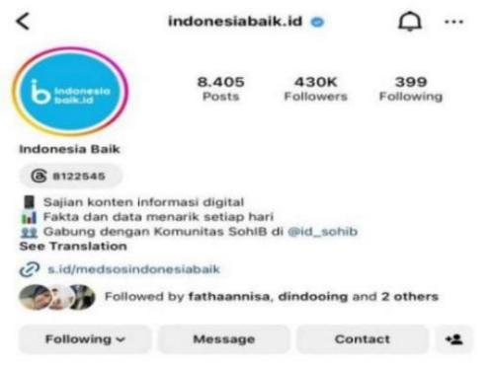  *Data as of 8/7/2023
Twitter @IndonesiaBaikId | 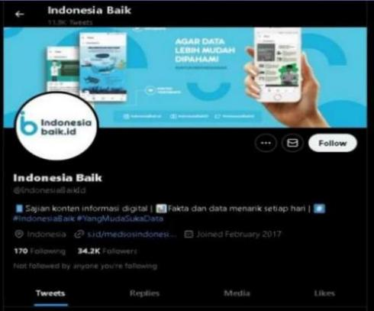  *Data as of 12/7/2023
FacebookIndonesiaBaikId | 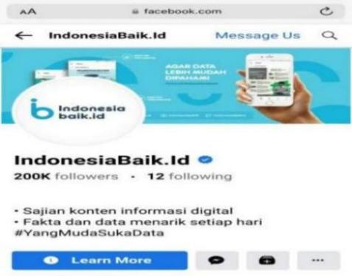  *Data as of 12/7/2023
YouTube IndonesiaBaikID | 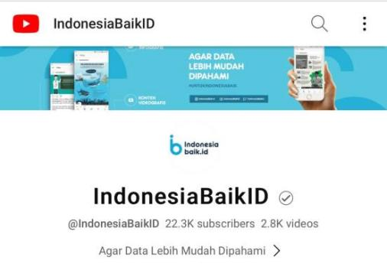  *Data as of 12/7/2023
TikTok @indonesiabaik.id | 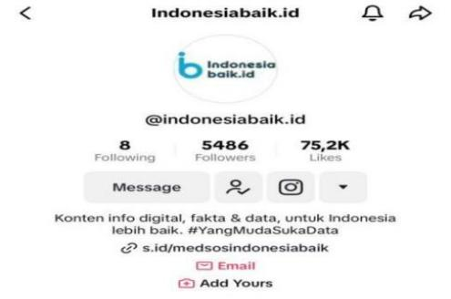  *Data as of 12/7/2023

The choice of Instagram social media is because it is considered more relevant to spread the type of content from Indonesiabaik.id and attract the involvement of the community, especially the younger generation as the target audience of Indonesiabaik.id, namely the age of 18 to 34 who are critical, starting to care about the government, and the majority are included because of infographic content. The @indonesiabaik.id account as a media from the Ministry of Communication and Information in disseminating public information about various government institutions such as ministries and non-ministries is motivated by the implementation of Presidential Instruction No. 9 of 2015 through the Single Narrative. As part of the government, Indonesiabaik.id uses social media to encourage public information disclosure as a form of transparency in realizing good governance. As revealed by informant 1: "We want to realize good government or one of them is government transparency to the public. Indonesia Baik is specific, for example, the target is for young people aged 18-34 years because the target may be with information in the government not reaching them, so yes, the purpose of Indonesia Baik is to convey information in a way that is easier for our teenagers to understand, but so that the truth is maintained so that it does not become gossip, we also always insert data. That's why the tagline we bring is "Young People Love Data."
The @indonesiabaik.id account seeks to minimize the occurrence of misunderstandings that occur between the public and the government due to the lack of accurate information that circulates and the content cannot be accounted for as true or hoaxes in the community. The author also made indirect observations by observing the Instagram account @indonesiabaik.id, content posts uploaded on the @indonesiabaik.id account disseminated public information from various ministries and non-ministries, discussing government policies and programs, such as the Ministry of Health, the Ministry of Energy and Mineral Resources, the General Election Commission, the Ministry of Transportation, the Ministry of Religion, the National Police, BMKG, the Ministry of Environment and Forestry, Bank Indonesia, PSSI, the Secretariat Cabinet, BPJS, Ministry of PAN-RB, and others. The content uploaded by the @indonesiabaik.id account filters information such as one of which is being hotly discussed as an effort to socialize to the public, here are some content posts uploaded by the @indonesiabaik.id account.
In terms of public information presented in front of its followers, this account also pays attention to the type of public information needs it has. As we know that there are four information needs, namely the current need approach, everyday need approach, exhaustic need approach and Catching-up need approach (Fatmawati, 2015). The results and explanations include: 1. Current need approach, namely the management of information on social media based on public information needs as examples of information about BPJS health, anthrax diseases and others. 2. Everyday Need Approach: This approach focuses on meeting the needs of daily information that are routine and necessary for daily activities. This information helps the public carry out their daily activities better. Example: @indonediabaik Instagram account posts tips on choosing quality sacrificial animals and in accordance with sharia, another example: How to make a SIM C in detail. 3. Exhaustive Need Approach: This approach provides very detailed and comprehensive information. Usually, this is related to the topic of not being trapped in online gambling by providing a complete review, then about the Jabodetabek Light Rail Transit (LRT) public transportation as a government program to maximize mass transportation in cities. 4. Catching-up Need Approach: This approach focuses on meeting the needs of information for the public who want to catch up with information or events that have occurred. Example: This account highlights the needs of the 2024 CASN formation (Prospective State Civil Apparatus) then also about the Garuda National Team (Indonesian National Football Team that has the opportunity to qualify for the World Cup, and others). The bottom line is that social media can be more effective in conveying information according to the specific needs of its public, ensuring that they get relevant and timely information.

Table 2. Account Information Description for Public
Indonesiabaik.id Instagram Account Content | Description
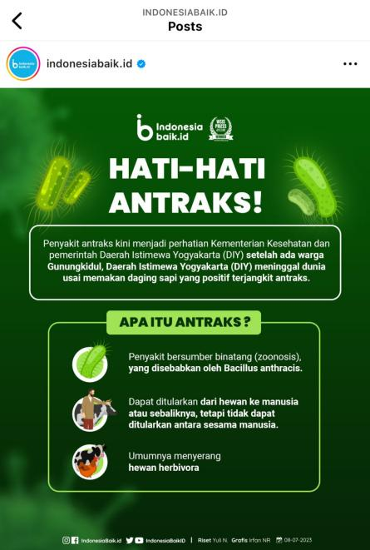  Source: Ministry of Health | On June 8, 2023, the Instagram account @indonesiabaik.id uploaded content regarding information about anthrax disease. The disease has become a concern of the Ministry of Health and the Yogyakarta Instimewa Regional Government because it has caused some residents of Gunung Kidul Regency to die. In the content, it informs about what Anthrax disease is and how to prevent it. This is related to the lives of the people and public order.
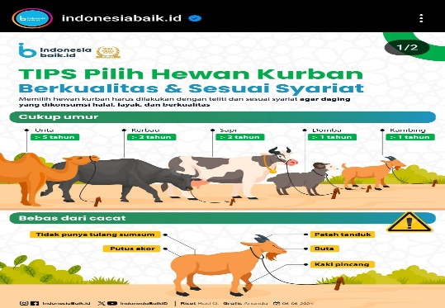 | On June 10, 2024, the Instagram account @indonesiabaik.id uploaded public information content regarding tips for choosing quality sacrificial animals and in accordance with sharia
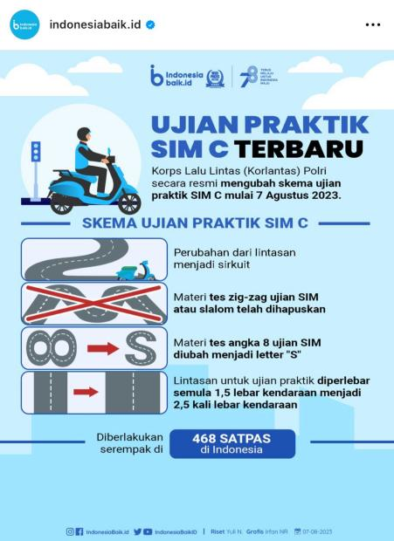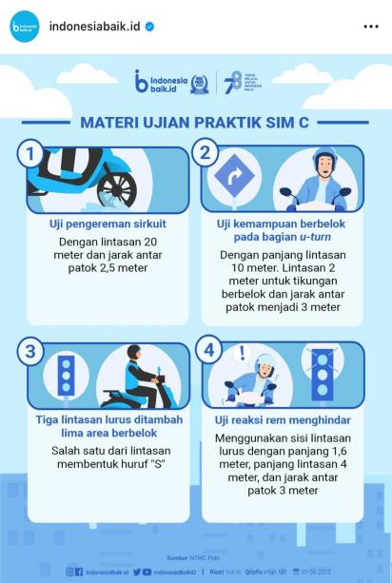  Source: Korlantas Polri | On August 8, 2023, the Instagram account @indonesiabaik.id uploaded public information content regarding the latest policy regarding the Driver's License (SIM) C practice exam issued by the National Police Traffic Corps (Korlantas) which will be enforced starting Monday, August 7, 2023. In the content uploaded by the @indonesiabaik.id account, it informs by displaying a schematic image of the SIM C practice exam along with some exam materials that need to be considered.
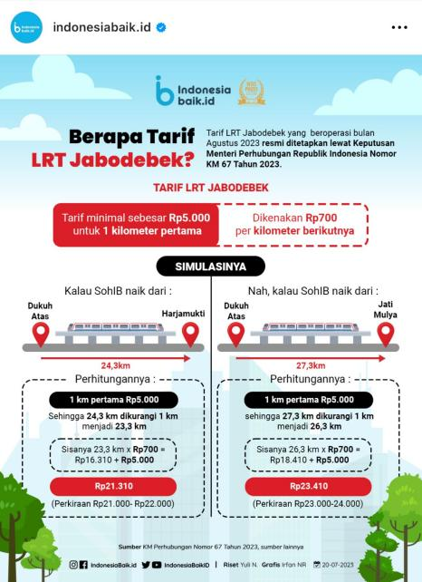  Source: Ministry of Transportation | On July 21, 2023, the Instagram account @indonesiabaik.id uploaded public information content about public transportation regarding the Jabodetabek Light Rail Transit (LRT) Train as a government program to maximize mass transportation in urban areas. In the uploaded content, it informs that the Jabodetabek LRT public transportation will start operating in August 2023 and describes the fares of the public transportation.

Instagram as a New Form of Media
Instagram as a new form of media, plays an important role in supporting the sustainability of @indonesiabaik.id account activities. As well as the interconnectedness, in this case, the internet is the main source of the presence of the @indonesiabaik.id Instagram account. This is because Instagram social media actually needs the internet to access. The @indonesiabaik.id Instagram account and its followers or other Instagram users exchange information supported by the internet so that there is a connection. Second, there is access to individual audiences as senders and recipients of messages. The @indonesiabaik.id Instagram account uses the direct message (DM) feature provided by Instagram as a means to send and receive messages that allow between fellow Instagram users or followers of the @indonesiabaik.id account in exchanging messages. Later the messages sent are private, only the sender and receiver will check it.
Instagram as a new media presents interactivity between users. In the Instagram account, @indonesiabaik.id uses one of Instagram's features, namely the comment feature, providing Instagram users to be able to interact in the comment column available in every uploaded content. The Instagram account @indonesiabaik.id responds to the comments of its followers regarding their opinions or perspectives on the uploaded content so that there is an interactive social interaction, by implementing two-way communication or more.
In this case, Instagram users can access information from the @indonesiabaik.id account open to anyone and the information disseminated by the @indonesiabaik.id account can be accessed anywhere and anytime and not limited by time. Then the findings in the 4 stages in the management of @indonesiabaik.id Account information are as follows.

Planning Stage
Defining Content Issues
Indonesiabaik.id planning the preparation of content to produce a content, starting from determining the issue. The choice of issues in the news is something that must be done for every media. Each media has its own strategy or way of choosing the issues that are developed in the news. In determining an issue to be discussed, Indonesiabaik.id refers to the four pillars that have been established as a reference in creating content. This is according to the statement of the results of the interview by the key informant "The content of the content, we have 4 pillars of government programs in accordance with our tagline, which is to be the main reference for government program information for the younger generation, so yes, government programs are definitely the main ones. Then the second is a daily issue or popular information in which there is a grid that is up-to-date, then there is a rather light one, then there is a third such as how to tips and tricks content, it's about Indonesia, content about Indonesia, for example, unique facts, for example, tourists in Bali are up, then the fourth is information education.
The issue that will be raised by the Instagram account @indonesiabaik.id refers to the agenda setting meeting with the Directorate of Media Management of Communication and Informatics as the one that oversees the running of the Indonesiabaik.id program and the internal meetings of the Indonesiabaik.id team. This was revealed by informant 1;" So what we plan the content will be approximately related to these 4 pillars. So, for example, the first one regarding government programs and public service education mostly refers to the agenda setting of the Directorate of Media Management, so if it was under the auspices of the Directorate General of IKP, then under it there is the Directorate of Media Management. Every week we have an agenda setting to determine what priority issues must be conveyed to the community. Of those priority issues, we are in terms of limited content production, we only have 24 content in one week. So the priorities are divided, while the setting agenda is usually very many issues that must be discussed, so we sort out which one is approximately a priority, the same for a year, usually we also refer to the government's Priority Work Plan (RKP) which has been planned by the President. Then from the agenda setting of the week after we sorted it, we input, especially in government programs and public service information education, after that we divided it again for a week we made a team discussion plan, later after we agreed then we submitted it to the Directorate, this content is what we make for the next week. Then another pillar of the daily issue, we usually look at what is crowded and then we decide whether to raise it or not. After we decide to appoint a new one, from there we determine what kind of content the format will be, usually the daily issue is still not far from the government program, so 75% of our content is related to the government. Only then is the last thing about Indonesia that we usually relax like for example information about the largest cinema in Indonesia or maybe the area of Indonesia or the area of a region"
The agenda setting meeting is carried out every week and the internal team Indonesiabaik.id hold a meeting every day to determine the issues to be raised. The issues discussed in the agenda setting meeting will later be selected by the Indonesiabaik.id team in an internal meeting. Instagram @indonesiabaik.id in determining the issue to produce a content refers to the agenda setting at the Directorate of Media Management of the Directorate General of Information and Public Communication of Kominfo which is carried out once a week, the issues discussed from the agenda setting meeting are usually based on the public interest that must be conveyed, after the agenda setting meeting an internal meeting will be held every day to sort out the issues from the agenda setting meeting and determine what issues will be made into a content.

Organizing Stage
In media organizations, there are various jobs that need to be regulated in a labor division structure. The organization in Indonesiabaik.id is structurally headed by the editor-in-chief. In addition, in producing the content of the @indonesiabaik.id account, there is a technical production department that is arranged by the editor and assisted by several teams. This was conveyed by a key informant: "The staff is outside of me, yes, if from the official structure that is a civil servant, there is the Director in charge of the editor, then there is Mas Dimas the deputy editor-in-chief, then there is me as the managing editor who is a civil servant. If technically there are 10 people consisting of 1 editor who is in direct contact with children to manage their content, then there are 2 copywriters who make content scripts, 2 graphic designers, 2 content creators or video editors for short videos, 1 data base, 1 social media coordinator or social media analyst as a social media admin overall, on social media, we also seconded friends of public relations from civil servants Kominfo, each social media has an additional admin, finally 1 IT team whose focus is on managing Indonesiabaik.id website. That's 10 people." This is also supported by informant 1, saying that: "There are 10 in addition to the managing editor, deputy editor-in-chief, and editor-in-chief." Assignment in producing content, there is a division of small teams that are responsible for creating one content consisting of 1 team of 3 people. This was conveyed by the Key Informant saying that: "This task is specifically for the content team, yes, we have 2 copywriters, scriptwriters, 2 designers, 2 video editors. That week we had about 27 content consisting of 20 infographics and 7 videos. It is to be made in 5 days. Now that's what determines it, it's clear that 1 team consists of 3 people in making 1 content."
The stage of organizing the management of content production on social media issued Indonesiabaik.id coordinated by the editor in charge of the production process, the copywriter in charge of content writing, the graphic design in charge of visual design for infographics, the video editor in charge of making videos. Meanwhile, the person responsible for technical social media management is a social media specialist.

Actuating Stage
Planning and organizing will not run well if it is not followed by the implementation of responsible organizational work. The implementation of work must be in line with the work plan that has been prepared. Actuating includes leadership and coordination. At the implementation stage, it includes two things, namely the process of compiling or writing a message and the process of delivering a message. The @indonesiabaik.id account displays content that is timeless or the information is not limited to a certain time range in compiling messages. Indonesiabaik.id confirm that the content of the content is valid, they include the date of production and the source in the content created. This was revealed by informant 1, saying that: "One way to make our content valid, we always include the source in our content and the date of production. So if there is a problem like earlier, we produce content, for example, on the 12th, then there is a virtual problem and we have to change, even if the change is only one or two sentences, the content will be revised and we will give the production on a new date. The problem is that there have been incidents, especially when we talk about data, for example, this data is valid for now but next year it is not necessarily or it may not be valid." In carrying out the task, leadership plays an important role in providing direction. As for the briefings carried out in, the running Indonesiabaik.id is more than one for the content that is simple and not convoluted. As well as trying to build communication by coordinating directly with the Indonesiabaik.id team, providing direction when there is content to be created.

Controlling Stage
The supervision stage is carried out so that unexpected things do not happen or minimize unexpected things. As for conducting supervision to prevent errors, content is re-checked by editors in accordance with the existing SOP (System Operation Prosedure). This supervision stage also returns to the editorial meeting which brings together the editor-in-chief, with the ranks of the editorial team under him, to find out the progress of their work so that it can be used as material for consideration and evaluation. This was conveyed by the key informant, Andrean Finaka as the managing editor of Indonesiabaik.id, said that: "We have a report every month that this content has been made anything, how much exposure, how much engagement, then which content has the highest viewers and which viewers are the lowest. Well, that's it, so we can see that later if from this low content, we will try to analyze whether the content is not right, whether the timing is not right, so we try to analyze every month, we improve it, we develop it again, for example, in terms of the content, in terms of the time of the post, and in terms of the content. The evaluation meeting in the latest year is once a month, including the evaluation is delivered by the director or sub-directorate coordinator. For the team, the brefing is carried out daily and weekly, yes, the whole team.
Management on social media Intsgram @indonesiabaik on the implementation of social media management based on the 4Cs (Context, Communication, Collaboration, Connection):
- Context @indonesiabaik.id by managing messages to be conveyed in accordance with 4 pillars, namely government programs, popular information, information education and about Indonesia. The tagline is 'The Young People Like Data' as complete as possible to be the main reference for government program information for the younger generation, the language is made simple, not complicated, and displays interesting visualizations so that data that can be accepted by the public that is easy to understand, easy to understand and easy to obtain
- @indonesiabaik.id Communication Management is the management of delivering messages so that they can be understood so that they can stay connected with their followers or followers, such as following developments by looking at content trends spread on Instagram. Using short videos whose frames are upright is not horizontal according to the tastes of the younger generation.
- @indonesiabaik.id In fulfilling the information to be presented, by managing collaboration with related parties in publishing information, @indonesiabaik.id disseminates public information from various ministries and non-ministries, discusses government policies and programs, such as the Ministry of Health, the Ministry of Energy and Mineral Resources, the General Election Commission, the Ministry of Transportation, the Ministry of Religion, The National Police, BMKG, the Ministry of Environment and Forestry, Bank Indonesia, PSSI, the Cabinet Secretariat, BPJS, the Ministry of PAN-RB, and others. The Instagram account @indonesiabaik.id also has a training community called SohIB to establish relationships with its followers
- Connection Management @indonesiabaik.id Connection management is sustainable with the aim of maintaining relationships between followers and establishing closeness. Conduct Two-Way Communication, which means that the @indonesiabaik.id account also implements two-way communication to its audience, such as using captions containing questions, especially followers to give each other feedback on published information. Always do quick responses, @indonesiabaik.id account using the comment feature
Overall, in the process of managing the @indonesiabaik.id account, there are obstacles, among other things, because in the process of producing content the @indonesiabaik.id account is still constrained by time, such as in following issues that are being hotly discussed by the public, the @indonesiabaik.id account has to wait for official sources for data due to the absence of field coverage. In addition, there are limited human resources both in the production process and social media admins, especially Instagram.

CONCLUSION
Indonesiabaik.id uses Instagram as a new media platform to disseminate public information about the government. The platform follows Denis McQuail's New Media theory, involving planning, organizing, implementing, and supervising content. The content is prepared through agenda setting, internal team meetings, and small teams of three people. Implementation involves writing content, designing infographics or short videos, and uploading content. Supervision is carried out through evaluation meetings with the editorial board and internal evaluations every week. Social media management is based on the 4 Cs analysis, including managing context, communication, collaboration, and connection with information sources, particularly with younger generation followers. Future research should explore the effectiveness of content strategies, including how different formats impact user engagement, retention, and information dissemination. Additionally, investigating audience feedback and interaction could provide insights into optimizing social media strategies for public information dissemination.

REFERENCES
Annur, C. M. (2023). Survei KIC: Mayoritas Masyarakat Indonesia Mengakses Informasi di Media Sosial. Katadata Media Network.
APJII. (2023). Pengguna Internet Indonesia 215,63 Juta pada 2022-2023. APJII.
Fatmawati, E. (2015). Kebutuhan Informasi Pemustaka dalam Teori dan Praktek. Info Persada.
Hastrida, A. (2021). Process of Government Social Media Management : Benefit and Risk. Jurnal Penelitian Komunikasi Dan Opini Publik, 25(2).
Imamov, M., & Semenikhina, N. (2021). The impact of the digital revolution on the global economy. Linguistics and Culture Review, 5(S4). https://doi.org/10.21744/lingcure.v5ns4.1775
Khan, M. N., Ashraf, M. A., Seinen, D., Khan, K. U., & Laar, R. A. (2021). Social Media for Knowledge Acquisition and Dissemination: The Impact of the COVID-19 Pandemic on Collaborative Learning Driven Social Media Adoption. Frontiers in Psychology, 12. https://doi.org/10.3389/fpsyg.2021.648253
Kington, R. S., Arnesen, S., Chou, W.-Y. S., Curry, S. J., Lazer, D., & Villarruel, A. M. (2021). Identifying Credible Sources of Health Information in Social Media: Principles and Attributes. NAM Perspectives. https://doi.org/10.31478/202107a
Kominfo. (2017). Situs Ini Lahir karena “Terinspirasi” Hoax. Kominfo.
Kominfo. (2018). Program Indonesiabaik.id Kemkominfo Raih Penghargaan Tertinggi PBB. Kominfo.
Marani, I. N., Subarkah, A., & Wijayanto, A. (2020). The Use of Computer Mediated Communication (CMC) in Distance Learning During Covid-19 Pandemic: Pros and Cons. 6th International Conference on Social and Political Sciences (ICOSAPS 2020). https://doi.org/10.2991/assehr.k.201219.015
Mustapha, I., Khan, N., & Qureshi, M. I. (2022). Is Technology Affecting the Way Our Minds Operate? Digital Psychology of Users in the Era of Digitalization. In Advanced Structured Materials (Vol. 174). Springer. https://doi.org/10.1007/978-3-031-01488-8_8
Putri, A. V., & Irwansyah, I. (2020). Communication Patterns and Media Technology Role in Organization and Society During Pandemic. The Journal of Society and Media, 4(2). https://doi.org/10.26740/jsm.v4n2.p228-261
Solis, B., & Kutcher, A. (2010). Engage: The Complete Guide for Brands and Businesses to Build, Cultivate, and Measure Success in the New Web. Wiley. https://books.google.co.id/books?id=AUczMkQo5F4C
Szymkowiak, A., Melović, B., Dabić, M., Jeganathan, K., & Kundi, G. S. (2021). Information technology and Gen Z: The role of teachers, the internet, and technology in the education of young people. Technology in Society, 65. https://doi.org/10.1016/j.techsoc.2021.101565
Thompson, N., Wang, X., & Daya, P. (2020). Determinants of News Sharing Behavior on Social Media. Journal of Computer Information Systems, 60(6). https://doi.org/10.1080/08874417.2019.1566803
Tsfati, Y., Boomgaarden, H. G., Strömbäck, J., Vliegenthart, R., Damstra, A., & Lindgren, E. (2020). Causes and consequences of mainstream media dissemination of fake news: literature review and synthesis. Annals of the International Communication Association, 44(2). https://doi.org/10.1080/23808985.2020.1759443
Vraga, E. K., & Tully, M. (2021). News literacy, social media behaviors, and skepticism toward information on social media. Information Communication and Society, 24(2). https://doi.org/10.1080/1369118X.2019.1637445
We are Social. (2023). Digital 2023: Global Overview Report. We Are Social.
Wukich, C. (2022). Social media engagement forms in government: A structure-content framework. Government Information Quarterly, 39(2). https://doi.org/10.1016/j.giq.2022.101684
Yuan, Y. P., Dwivedi, Y. K., Tan, G. W. H., Cham, T. H., Ooi, K. B., Aw, E. C. X., & Currie, W. (2023). Government Digital Transformation: Understanding the Role of Government Social Media. Government Information Quarterly, 40(1). https://doi.org/10.1016/j.giq.2022.101775

